

CAPSTONE PROJECT REPORT
Report 5 – Software Test Documentation

– Ho Chi Minh, October 2026 –
Table of Contents
I. Record of Changes 3
II. Testing Documentation 4
1. Scope of Testing 4
1.1 Features and Functions to Be Tested 4
2. Test Strategy 9
2.1 Testing Types 9
2.2 Test Levels 9
2.3 Supporting Tools 10
3. Test Plan 10
3.1 Human Resources 10
3.2 Test Environment 11
3.3 Test Milestones 11
4. Test Cases 12
5. Test Reports 12

I. Record of Changes
Date | A*  M, D | In charge | Change Description
13/10/2026 | A | Tran Ngoc Khiet | Version 1.0  Add:  FSCM Scope of Testing, Test Strategy and draft Test Plan  Identify pending test decisions.
27/10/2026 | M | Doan Duc Hai | Version 1.1  Modify:  - Expand Scope of Testing to the current FSCM feature list and roles.  - Update Test Strategy, Supporting Tools and Test Plan for the implemented technology stack.
28/10/2026 | M, A | Doan Duc Hai | Version 1.2  Modify:  - Align in-scope payment, pricing, MLOR, allocation, offline, picking, delivery, refund and loyalty test rules (R5-01–R5-08).  - Update NFR strategy, FEFO evaluation, test environments and exit criteria (R5-11–R5-12).  - Refresh module-level requirements and test summaries using the finalized Unit Test v1.2 and Test Report v1.2.  Add:  - Present Section 4 test cases and Section 5 execution summaries through the two FSCM Excel workbooks only (R5-09–R5-10).
28/10/2026 | M | Doan Duc Hai | Version 1.3  Modify:  - Apply approved F1–F5 business choices: 00:00 ICT, percentage-only discounts, 1 point / 10,000 VND, full receipt, positive net price, Administrator/Operator product permissions and staff gift completion.  - Align group promotions, allocation tie-break, transfer verification timing and P1/C1/P2/SHORT fixtures.  - Refresh referenced Unit Test v1.3 and Test Report v1.3 (192/271 planned, Not Run).
*A - Added M - Modified D - Deleted

II. Testing Documentation

1. Scope of Testing

1.1 Features and Functions to Be Tested
- Core Features: Authentication, User Account Management, Retailer Registration and Assessment, Product and Category Management, Warehouse Inventory, Sales Groups and Territory Permissions
- Order & Allocation Features: Sales Order capture and review, manual offline draft submission, approved allocation proposals, batch-level pricing, quotation acceptance, Prepaid bank transfer or Deferred payment, PO issuance, picking and dispatch
- Business Features: QR batch receiving and dispatch, quantity-based Retailer receipt confirmation, complaints and financial adjustments, approved Prepaid/Deferred collections, manual refunds, loyalty, staff-confirmed gift delivery and reports
- Admin Features: Configuration of Warehouses, Distance and Transit Rules, Product Publication, Retailer Approval, Allocation Runs, Write-Offs, Access Controls and Notifications
Feature | Function | Role | Description
Authentication | Login with system account | All roles | Test valid and invalid credentials, account status, token issuance and authorized access.
Authentication | Refresh and revoke session | All roles | Test refresh token rotation, expiry, logout and reuse prevention.
Authentication | Role and data-scope authorization | All roles | Test role-based actions, warehouse and retailer scope and forbidden cross-scope queries.
Authentication | Administrator user management | Administrator | Test account creation, updates, deactivation and restriction on Administrator provisioning.
Retailer Management | Declare retailer and assessment | Sales; Operator | Test retailer information, assessment fields, duplicate detection and pending-approval state.
Retailer Management | Review retailer activation | Administrator | Test approval/rejection, reviewer permission, reason and assigned retailer code.
Retailer Management | Manage retailer profile and MLOR | Administrator | Test retailer data updates, assigned coverage and category/SKU remaining-life policy.
Product Management | Manage category hierarchy | Administrator; Operator | Both authorized Administrator and Operator may create/edit category hierarchy; reject cycles and unauthorized writers, preserve dependent products.
Product Management | Create and publish product | Administrator; Operator | Both Administrator and Operator may create, price, edit Draft, Publish and inactivate products with scoped authorization. Published SKU is immutable; replacement Draft has distinct SKU without transferring historic stock or orders.
Product Management | Product search and catalog visibility | Sales; Retailer; Administrator | Test searching, filtering and visibility of published products for permitted roles.
Promotion Management | Manage ordinary promotion | Administrator | Group promotion threshold sums quantities across eligible SKUs within ONE Sales Order (A6+B4 qualifies for 10); choose best valid promotion per line with deterministic code tie-break. No stacking or cross-order aggregation.
Promotion Management | Calculate shelf-life discount tier | Administrator; System | Apply percentage-only shelf-life tiers (strictly under 100%) after batch MLOR eligibility and ordinary group promotion; SKU tier overrides Category; use batch-specific VND rounding, reject fixed amount and final unit price <=0, preserve split snapshots and net-price refunds.
Promotion Management | Retain MLOR eligibility despite discounts | System; Administrator | Validate SKU > Category > product default MLOR at ETA before any price reduction. Discount cannot relax eligibility; offer-specific MLOR override stays outside scope.
Sales Order & Quotation | Capture Sales Order for assigned Retailer | Sales | Capture an indicative Sales Order without selecting a batch or holding stock; snapshot permitted retailer, SKU, price/promotion and current MLOR; prepare for Operator review, allocation, quotation and eventual PO conversion.
Sales Order & Quotation | Validate order quantity and captured conditions | Sales | Test quantity multiples, bounds, request version and no early stock reservation. Order creation is not PO issuance.
Sales Order & Quotation | Review or reject Sales Order before cutoff | Operator | Review before the 00:00 ICT daily cutoff; verify reason, authority and reviewed timestamp. Neither review nor capture reserves stock or produces a PO.
Sales Order & Quotation | Cancel Sales Order or quotation with evidence | Sales; Operator; Administrator | Verify state-specific cancellation authority, reason, evidence, released reservation and refund obligation when paid; do not auto-return physical stock.
Sales Order & Quotation | View scoped order history | All permitted roles | Test order status timeline, filters and visibility restricted by retailer or sales scope.
Offline Synchronization | Save offline order to local queue | Sales | Test draft persistence, device order code, UUID and unsynchronized status.
Offline Synchronization | Manually submit offline drafts | Sales | Reconnection alone NEVER uploads local drafts. Sales explicitly selects Send; server checks current pricing, promotions, MLOR and retailer scope; changes require review/confirmation before acceptance.
Offline Synchronization | Retry an explicitly sent request safely | Sales; System | Technical retries use the SAME key and payload without duplicating the order or changing confirmed terms. Edited payload uses a NEW request key; no implicit submit on reconnect.
FEFO–MLOR Allocation | Create 00:00 ICT daily allocation run | System Scheduler | Verify both server-acceptance and Operator-review timestamps strictly before 00:00 Asia/Ho_Chi_Minh; exact/late timestamps defer; month/year boundaries, device-clock independence, priority by server time then code, once per local business day.
FEFO–MLOR Allocation | Filter batch eligibility before any discount | System | Verify available/unlocked SKU batch, expiry, service distance, predicted arrival, deadline and effective MLOR (SKU > Category > product default). Discount never makes an ineligible batch eligible.
FEFO–MLOR Allocation | Score batches with no later-order swaps | System | Weighted score 0.5 fE + 0.3 fD + 0.2 fQ; tie-break ONLY on equal score: earliest expiry -> shorter warehouse distance -> ascending batch code. Never swap batch already assigned to earlier order; benchmark same eligible pool.
FEFO–MLOR Allocation | Reject short orders and re-pool stock | System | All-or-nothing per Sales Order; tentative draws returned on shortage. Creating a new order after a short result assigns a NEW server acceptance time, without preserving its former priority.
FEFO–MLOR Allocation | Review proposal and approved batch prices | Administrator | Verify proposal/version and price approval; stale revision/recalculation requires reason and new version; tentative plans do not reserve stock.
FEFO–MLOR Allocation | Reserve after Admin approval and issue quotation | Administrator; System | Revalidate and reserve atomically only after Admin approves allocation and batch prices; send time-limited quotation. PO and picking slips require Retailer acceptance plus eligible prepaid verification or approved credit term.
Warehouse Inventory | Create goods receipt and approve stock-in | Warehouse Keeper; Administrator | Test receipt details, approval, existing batch merge and traceable stock ledger.
Warehouse Inventory | View warehouse batch and stock | Warehouse Keeper; Administrator | Test OnHand, Reserved, Available, batch expiry and warehouse-scoped access.
Warehouse Inventory | Detect expiry and inventory lock | System | Test near-expiry and expired state, locked quantities and safe repeated sweeps.
Warehouse Inventory | Write-off unusable quantity | Warehouse Keeper; Administrator | Test valid reason/evidence, approval, remaining balance and movement audit.
Warehouse Inventory | Generate and split batch QR label | Warehouse Keeper | Test QR batch identity, maximum quantity, parent–child lineage and idempotency.
Picking & Dispatch | Issue picking lists only for eligible POs | System; Warehouse Keeper | Verify Sales Order -> approved priced proposal -> reserved stock -> accepted quotation -> prepaid verification or approved credit -> PO -> one picking slip per warehouse, exactly once.
Picking & Dispatch | Scan picking and resolve exceptions | Warehouse Keeper; Administrator | Verify batch/warehouse scan, all warehouse portions Ready, open pick exception or inventory lock blocks readiness/dispatch; only designated Administrator can resolve exceptional recovery/cancellation.
Picking & Dispatch | Gate dispatch and ensure idempotency | Operator; Warehouse Keeper | Deny dispatch if PO missing, prepaid not verified, any warehouse not ready, open lock/exception or invalid assignment; OnHand is decremented only on accepted dispatch; repeated confirmation has no double stock effect.
Delivery & Receipt | Assign vehicle and driver | Operator | Test permitted vehicle/person assignment, completeness and shipment-level snapshot.
Delivery & Receipt | Confirm actual Retailer receipt by shipment | Retailer | Validate received=0 and partial receipt, missing=expected-received, damaged<=received and QR scope. Every unit across all shipments must be physically received before Delivered AND Completed; financial settlement alone cannot complete missing quantities.
Delivery & Receipt | Record discrepancy and authorized settlement | Retailer; Operator; Administrator | Preserve missing/damaged evidence, net-batch-price adjustment and role-specific retry/settlement; settlement never falsely marks unreceived units physically delivered, completes order or grants points. No automatic stock return.
Payment & Finance | Record prepaid or deferred payments; reject COD | Retailer; Sales; Operator | COD and prepaid cash requests must be REJECTED. Prepaid bank transfer is submitted/verified after approved quotation pricing and before PO/dispatch; deferred requires approved Retailer payment term. Credit cash collections only after delivery by assigned Sales; transfer verified by authorized staff.
Payment & Finance | Separate quote/prepaid deadline and credit due date | Operator; System | Prepaid verification deadline follows quotation/dispatch window; deferred credit due date is calculated from confirmed actual receipt date and versioned Retailer term. No COD due date.
Payment & Finance | Manage manual refund evidence lifecycle | Operator; Administrator | Validate refund cap based on paid net amount, transfer proof, rejected evidence -> supplementation -> separate Administrator verification; verification must NOT deduct loyalty points again.
Payment & Finance | Approve complaint-based financial adjustment | Operator; Administrator | Compute at affected allocated batch net unit price x accepted quantity with rounding and cap; prevent duplicates and double ledger changes; never automatically return physical stock.
Loyalty Management | Earn points once after complete receipt | System | After ALL physical quantities are received, payment fully settled and no complaint open, post points once at floor(eligible net VND / 10,000): P1 612,000 -> 61 points. Approved 72,000 adjustment after Completed corrects eligible value to 540,000 -> 54 points, correction -7; negative balance may remain.
Loyalty Management | Redeem gifts and complete via authorized staff | Retailer; Administrator; Operator | Retailer requests, points and gift stock held; authorized Administrator/Operator approves, records physical delivery evidence and completes gift. Retailer confirmation is NOT a mandatory additional step; reject/cancel releases holds once, no duplicate debits.
Loyalty Management | Manage loyalty program and available gifts | Administrator | Validate program eligibility, configured 1 point/10,000 VND fixture, reward-stock thresholds and authorized staff gift completion after delivery evidence; no early points for missing stock.
Sales Group Management | Manage sales groups and coverage | Sales Manager | Test group assignment, regional restrictions, member history and access scope.
Operational Reporting | View authorized sales dashboard | Administrator; Sales Manager; Sales | Test role-based KPI filters, visible teams and best-selling product calculations.
Operational Reporting | Calculate net revenue after adjustments | Administrator; Sales Manager | Test promotion deduction, completed-order eligibility and financial corrections.
System Configuration | Version transit distance and ETA rules | Administrator | Test non-overlapping distance bands, versioned rules and configured receipt ETA.
System Configuration | Warehouse location and map distance | Administrator | Test location updates, provider failures and route distance validation.
Notification | Send operational notification | System | Test recipients, persisted outcomes and external push errors without changing business state.
Sales Order & Quotation | Accept priced quotation and convert to PO | Retailer; Operator | Test quotation acceptance before deadline, valid Prepaid bank transfer verification or approved Deferred term; duplicate PO prevention; no picking or dispatch from unconverted Sales Order.
Delivery & Receipt | Delivery attempt retry or exception settlement | Operator; Administrator | Test failure reason/evidence, bounded retry only while ETA/MLOR/deadline valid, Administrator-only settlement decision and no automatic inventory restock.
Loyalty Management | Post adjustment after order Completed | System; Administrator | Reconcile points by source financial adjustment once; allow negative corrected balance; prevent double deduction on manual refund verification.
FEFO–MLOR Allocation | Compare weighted allocation against strict FEFO | System; QA | Same eligible batches, order priority and all-or-nothing; report completed/short orders, near-expiry quantity, mean distance, warehouse count and runtime without an optimality claim.
Quality Attributes | Measure performance, resilience and data correctness | QA; Developer | Benchmark NFR-P01/P03/P06 and NFR-R01/R03/R04/R06, NFR-D01/D06 and NFR-O01/O03/O04; evidence-based thresholds and CI/test reports.
Scope Exclusion | Reject COD and near-expiry MLOR override | System; QA | Negative tests verify COD is unavailable and manual near-expiry offer selection never overrides configured MLOR; future-scope features are excluded from success paths.

- Scope boundary (v1.3): COD success and prepaid cash success are excluded; their requests must be rejected without business side effects. A shelf-life discount never relaxes the effective MLOR, and near-expiry offer acceptance that overrides MLOR is outside the tested scope. Offline drafts require explicit Sales submission; warehouse internal transfers and claims of global allocation optimality are excluded. Daily allocation applies the 00:00 Vietnam-time cutoff, server-side acceptance/review timestamps and all-or-nothing fulfillment. Shelf-life discount tiers are PERCENTAGE ONLY (<100%) and final unit price must be >0; Administrator and Operator may manage Product. Points are floor(net eligible VND / 10,000). Gift completion uses authorized staff delivery evidence.

2. Test Strategy

2.1 Testing Types
Test Type | Objective | Technique | Completion Criteria
Functional Testing | Verify all in-scope FSCM requirements, permitted actor actions and mandatory business paths. Apply F1–F5 authorized roles, SO/PO transitions, group promotions and full-receipt completion. | Traceable positive/negative/boundary/state cases; requirement and business-rule references. | Overall pass >=90%; 100% mandatory main paths executed and passed; no open Critical/High defects.
Unit Testing | Verify business-rule calculations, concurrency guards, idempotency, state transitions and price/loyalty arithmetic. | xUnit .NET 10; flutter_test; deterministic fakes/fixtures; coverage via coverlet. | Unit cases executed as applicable, with actual CI evidence and measured coverage reported; unexecuted cases remain Not Run.
Integration Testing | Validate API/persistence, inventory, payment, authorization, configured external services. | ASP.NET TestServer; REST commands and read-only GraphQL where approved; payOS sandbox/webhook only if in approved architecture; transactional checks. | Critical integration paths verified using approved REST/GraphQL/payOS contracts where applicable; no unexpected 5xx or inconsistent stock/payment writes.
UI/UX Testing | Check portal and mobile operation for supported roles. | Manual browser/device walkthroughs; navigation, validation and state feedback. | No blocking UI issues; primary role journeys can be completed.
Security Testing | Validate access control and protection of business data. | Authentication/role checks; warehouse, retailer and sales-scope negatives. | No unauthorized data/action access; no Critical/High security defects.
Acceptance Testing | Demonstrate mandatory Sales Order → allocation → quotation → PO → picking → delivery → finance/loyalty journeys. Use P1/C1/P2/SHORT and F1–F5 evidence. | Role-based UAT with evidence, actual outcomes and sign-off; no substituted BM02 review outcomes. | All mandatory main paths pass; overall pass >=90%, zero open Critical/High and stakeholder approval.
Performance & Reliability Testing | Quantify API latency, allocation runtime, offline durability, duplicate resistance and recovery behavior. | k6, 50 VUs/10 min, p95 read/write, generated 300x5 orders/20k batches/5 warehouses, 50 concurrent writes, forced failures and replay. | NFR-P01: read <=1s; write <=2s; errors <1%. NFR-P03: allocation <=5min; approval <=30s. NFR-R03/R04: zero duplicates/negative balances. All measured, not assumed.
Algorithm Evaluation | Compare weighted greedy FEFO-MLOR against strict FEFO under identical eligible data and order priorities. | Identical snapshot, eligibility, all-or-nothing rules, tie-break and machine; collect completed/short orders, near-expiry units, distances, warehouses/order and runtime. | NFR-D06: report each comparison, zero eligibility violations, no claim of global optimality.
Offline Resilience & Data Testing | Validate manual submission, stable request hash/idempotency, price/MLOR/retailer changes and storage continuity. | Android airplane mode, SQLite 200 drafts, 20 forced restarts, 10 duplicate submits, price/MLOR/scope conflict. | NFR-O01/O02/O03/O04 and NFR-P06 evaluated; reconnect never auto-sends; evidence recorded.

2.2 Test Levels
Type of Tests | Test Level
Type of Tests | Unit | Integration | System | Acceptance
Functional Testing | X | X | X | X
Unit Testing | X
UI/UX Testing |  |  | X | X
Security Testing | X | X | X
Integration Testing |  | X | X
Performance & Reliability Testing |  | X | X
Algorithm Evaluation | X | X | X
Offline Resilience & Data Testing | X | X | X

2.3 Supporting Tools
Purpose | Tool | Vendor/In-house | Version
Unit Testing | xUnit / flutter_test | .NET Foundation / Flutter | xUnit 2.9.3; Flutter 3.44 CI
Mocking | Test doubles / test fixtures | In-house | Project test classes
Coverage / API Load | coverlet.collector / k6 | Open Source | 6.0.4 / version recorded at run
API & Contract Testing | Swagger / TestServer; REST/GraphQL read; payOS sandbox | Microsoft / approved third parties | As approved SDD architecture; test environment versions recorded
Database / Metrics | PostgreSQL / DBeaver; Azure Monitor | Azure / DBeaver | PostgreSQL engine; exact service version verify in staging
Bug Tracking | GitHub Issues | GitHub | Project repositories
Test Management | Microsoft Excel | In-house | Report5 workbooks
Mobile / Offline | Flutter test / Android emulator or device / SQLite | Flutter / project team | Android 10+; test build and network profile logged
Algorithm Benchmark | Deterministic generator / timed FEFO runner | In-house | Identical eligible input and snapshot for weighted vs strict FEFO

- NFR measurement baseline: NFR-P01 50 VUs for 10 minutes (read p95 <=1.0s, write p95 <=2.0s, error <1%); NFR-P03 300 orders x 5 lines against 20,000 batches/5 warehouses (run <=5min, approval <=30s); NFR-R03 50 concurrent operations with zero negative stock and zero duplicate effects; NFR-R01 uptime >=99%, NFR-R02 RPO<=24h and RTO<=4h; NFR-O01–O04 manual offline submission, lossless queue and explicit conflict confirmation.
- FEFO evaluation protocol (NFR-D06): freeze seed, business-date clock, candidate eligibility, same server-priority order and expiry/distance/code tie-break, all-or-nothing rule and processing environment for weighted heuristic and strict FEFO. Save per algorithm complete/short order counts, near-expiry quantity, mean route distance, warehouses/order, run duration, eligibility violations and trace. Any favorable metric is a measured trade-off; global optimum is not claimed.
- Test reporting and exit policy: a case is Passed only after a dated execution, expected-versus-actual comparison and linked evidence. Cases without execution evidence remain Not Run, and blocked dependencies are marked Blocked. Test IDs, requirements, conditions, procedures, expected/actual outcomes and priorities are maintained exclusively in Unit Test and Test Report v1.3. Mandatory main paths must pass, overall pass >=90%, no open Critical/High defects; automation and coverage figures use measured CI evidence.

3. Test Plan

3.1 Human Resources
Worker/Doer | Role | Specific Responsibilities/Comments
Nguyen Thien Nhan | Leader | Lead business scope and review acceptance criteria; coordinate test priorities and sign-off.
Doan Duc Hai | Member | Coordinate Report 5; prepare test cases, verify backend test evidence and maintain test results.
Tran Ngoc Khiet | Member | Design and execute assigned backend, architecture and allocation-related tests.
Vo Minh Son | Member | Design and execute assigned web/mobile workflow and integration tests.
Truong Le Huy Hoang | Member | Design and execute assigned portal/mobile UI test scenarios.

3.2 Test Environment
Purpose | Tool | Provider | Version/Specs
Development | Localhost | Developer | ASP.NET Core .NET 10, React/TypeScript, Flutter
Backend CI | GitHub Actions | GitHub | Ubuntu 24.04; .NET 10; dotnet test
Frontend CI | GitHub Actions | GitHub | Node.js 22; npm ci, lint and build
Mobile CI | GitHub Actions | GitHub | Flutter 3.44.0; format, analyze, flutter test
Database | Azure Database for PostgreSQL + DBeaver | Microsoft Azure | PostgreSQL with EF Core; deployed database engine/build and migration version logged during test execution
Client Browser | Chrome / Microsoft Edge | Developer / Tester | Latest stable; mobile on test devices
Performance Test | Staging API; k6; Azure Monitor | Team / Azure | 50 VUs x 10 min; read/write p95, errors, CPU; baseline data version logged
FEFO / NFR Validation | Generated allocation data; CI tests; load harness | Team | 300 orders x 5 lines, 20,000 batches, 5 warehouses; deterministic seed; comparison metric files
External Integrations | REST/GraphQL + payOS sandbox where approved | Microsoft / payOS | REST commands, read-only GraphQL and payOS sandbox only where specified in the approved design; no test secrets in evidence

3.3 Test Milestones
Milestone Task | Start Date | End Date
Phase 1: Requirement Baseline and Unit Test Setup | 01/10/2026 | 18/10/2026
Phase 2: Feature Testing (Auth, Retailer, Catalog, Orders) | 19/10/2026 | 01/11/2026
Phase 3: Allocation, Integration and Offline Testing | 02/11/2026 | 09/11/2026
Phase 4: End-to-End, Security and NFR Testing | 10/11/2026 | 17/11/2026
Phase 5: UAT, regression, NFR evidence and release review | 18/11/2026 | 25/11/2026

4. Test Cases
- Unit Test Cases: Report5_Unit_Test_v1.3.xlsx
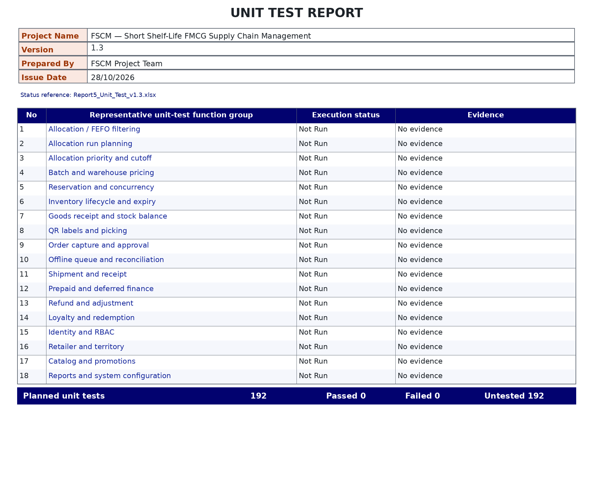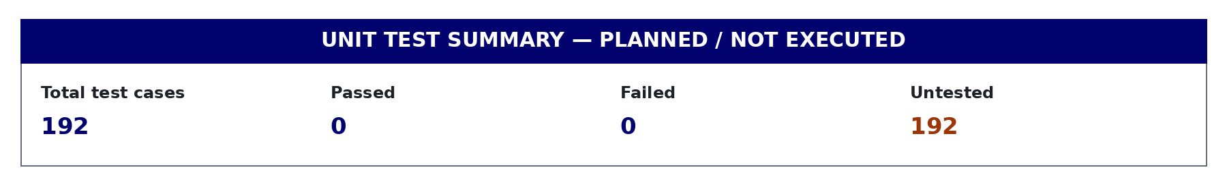

- Other Test Cases (IT, ST, AT, NFR): Report5_Test_Report_v1.3.xlsx
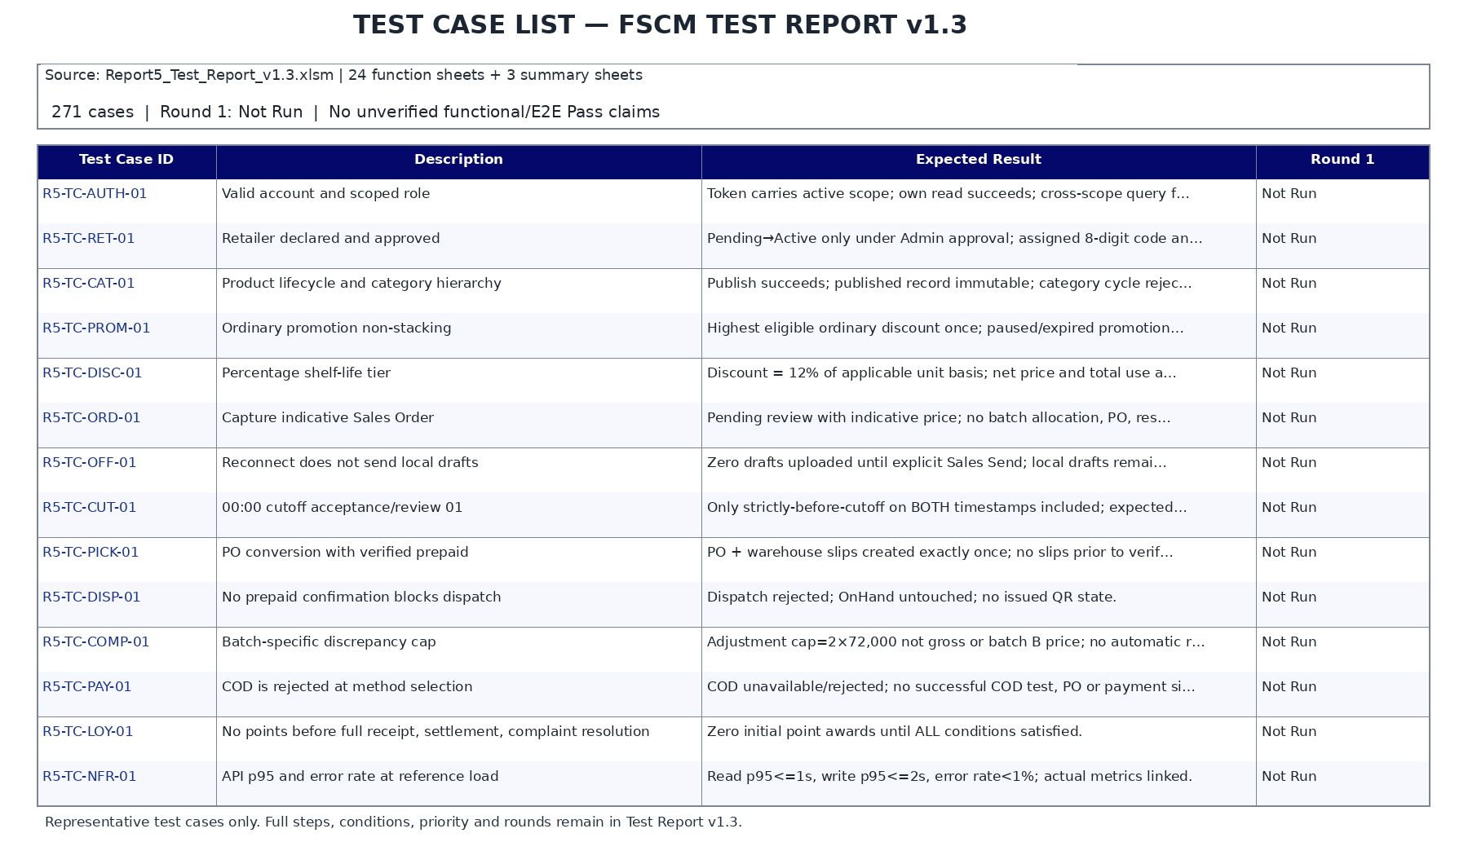
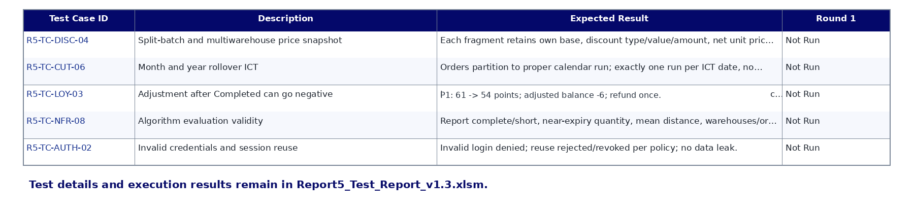

5. Test Reports
- Unit Test Report
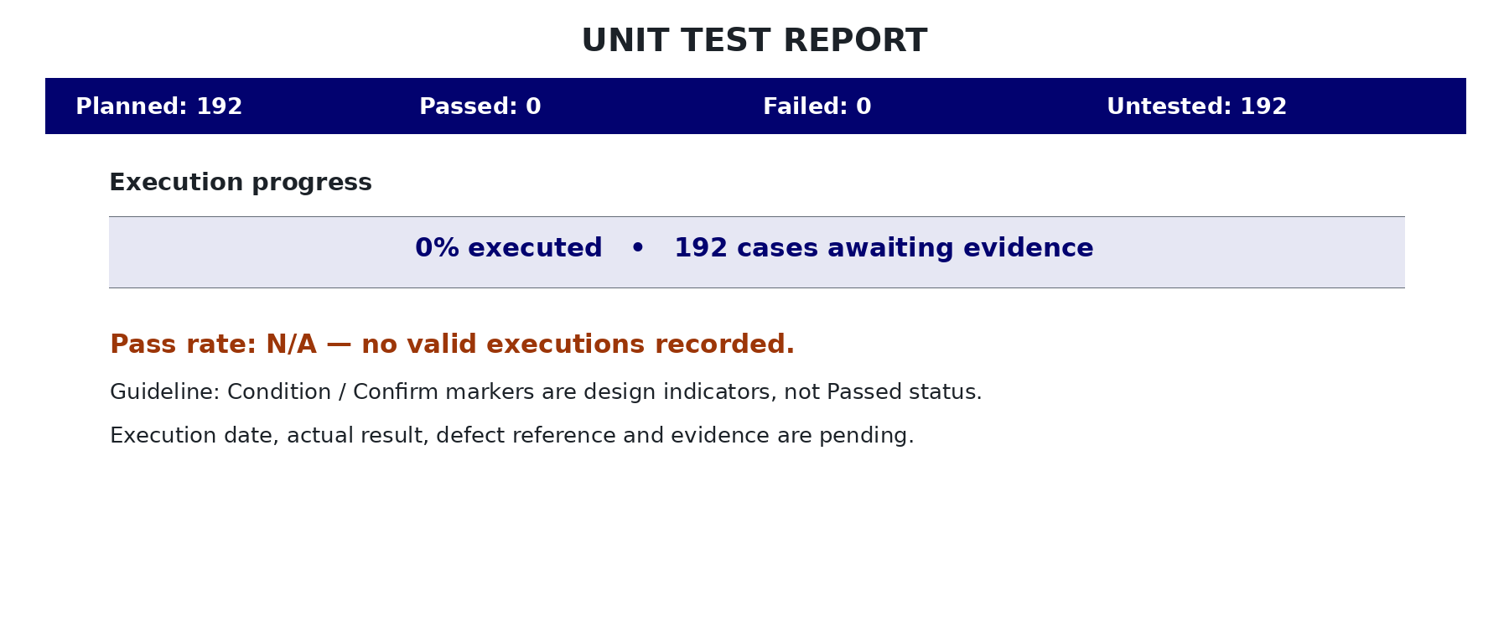

- Integration Test Report
